ITA0501-Computer Vision
Lab Experiments
1. Aim
To perform basic image handling and processing by reading an image in Python and converting the image into Gray-scale.
Algorithm
- Start the program.
- Import the OpenCV library.
- Read the input image using cv2.imread().
- Check whether the image is loaded successfully.
- Convert the color image into Gray-scale using cv2.cvtColor().
- Display the original image.
- Display the Gray-scale image.
- Save the Gray-scale image.
- Wait for a key press and close all windows.
- Stop the program.
Code
import cv2
# Read the image
image = cv2.imread("image.jpg")
# Check whether image is loaded
if image is None:
("Error: Image not found!")
else:
# Convert image to grayscale
gray_image = cv2.cvtColor(image, cv2.COLOR_BGR2GRAY)
# Display original image
cv2.imshow("Original Image", image)

# Display grayscale image
cv2.imshow("Grayscale Image", gray_image)
# Save grayscale image
cv2.imwrite("gray_image.jpg", gray_image)
print ("Image read successfully.")
print ("Image converted to grayscale successfully.")
print ("Grayscale image saved successfully.")
# Wait and close
cv2.waitKey(0)
cv2.destroyAllWindows()
Input:
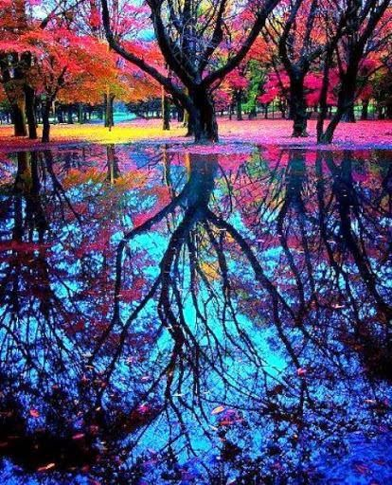
Output:
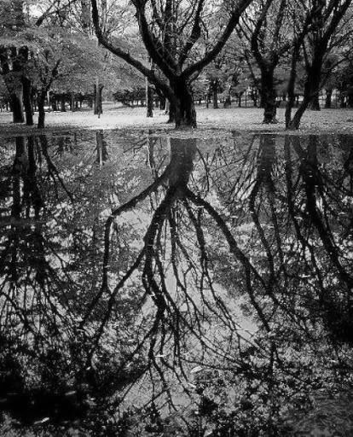
Result
Thus, the given image was successfully read using Python and converted from a color image to a gray-scale image using OpenCV.

2.Aim
To perform basic image handling and processing by reading an image in Python and applying Gaussian Blur to reduce noise and smooth the image.
Algorithm
- Start the program.
- Import the OpenCV library.
- Read the input image using cv2.imread().
- Check whether the image is loaded successfully.
- Apply Gaussian Blur using cv2.GaussianBlur().
- Display the original image.
- Display the Gaussian blurred image.
- Save the blurred image.
- Wait for a key press and close all windows.
- Stop the program.
Code:
import cv2
# Read the image
image = cv2.imread("image.jpg")
# Check image
if image is None:
print ("Error: Image not found!")
else:
# Apply Gaussian Blur
blurred image = cv2.GaussianBlur(image, (15, 15), 0)
# Display images
cv2.imshow("Original Image", image)
cv2.imshow("Gaussian Blurred Image", blurred_image)
# Save blurred image
cv2.imwrite("blurred_image.jpg", blurred image)
print ("Image read successfully.")
print ("Gaussian Blur applied successfully.")
print ("Blurred image saved successfully.")
cv2.waitKey(0)
cv2.destroyAllWindows()
Input:
Output:
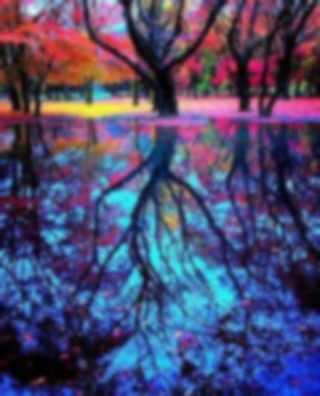
Result
Thus, the given image was successfully read using Python and Gaussian Blur was applied successfully to produce a smooth and blurred image.

3. Canny Edge Detection
Aim
To perform basic image handling and processing by reading an image in Python and detecting the outline/edges of the image using the Canny function.
Algorithm
- Start the program.
- Import the OpenCV library.
- Read the input image using cv2.imread().
- Check whether the image is loaded successfully.
- Convert the image into gray-scale.
- Apply the Canny edge detection function.
- Display the original image.
- Display the detected edges.
- Save the edge-detected image.
- Stop the program.
Code
import cv2
# Read the image
image = cv2.imread("image.jpg")
# Check whether image is loaded
if image is None:
print ("Error: Image not found!")
else:
# Convert image to grayscale
gray_image = cv2.cvtColor(image, cv2.COLOR_BGR2GRAY)
# Apply Canny edge detection
edges = cv2.Canny(gray_image, 100, 200)
# Display original image
cv2.imshow("Original Image", image)
# Display outline/edges
cv2.imshow("Canny Edge Image", edges)
# Save edge image
cv2.imwrite("canny_edges.jpg", edges)
print ("Image read successfully.")
print ("Canny edge detection applied successfully.")
print ("Edge image saved successfully.")
cv2.waitKey(0)
cv2.destroyAllWindows()
Input:
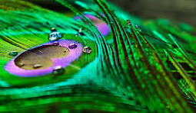
Output:
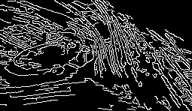
Result
Thus, the given image was successfully read and its outlines/edges were detected using the Canny edge detection function.

4. Histogram Equalization
Aim
To implement histogram equalization on the given image using OpenCV and compare the equalized image with the original image.
Algorithm
- Start the program.
- Import the OpenCV library.
- Read the input image.
- Check whether the image is loaded successfully.
- Convert the image into gray-scale.
- Apply histogram equalization using cv2.equalizeHist().
- Display the original gray-scale image.
- Display the histogram-equalized image.
- Save the equalized image.
- Stop the program.
Code
import cv2
# Read the image
image = cv2.imread("image.jpg")
# Check whether image is loaded
if image is None:
print ("Error: Image not found!")
else:
# Convert image to grayscale
gray_image = cv2.cvtColor(image, cv2.COLOR_BGR2GRAY)
# Apply histogram equalization
equalized_image = cv2.equalizeHist(gray_image)
# Display original grayscale image
cv2.imshow("Original Grayscale Image", gray_image)
# Display equalized image
cv2.imshow("Histogram Equalized Image", equalized_image)
# Save equalized image
cv2.imwrite("equalized_image.jpg", equalized_image)
print ("Image read successfully.")
print ("Histogram equalization applied successfully.")
print ("Equalized image saved successfully.")
cv2.waitKey(0)
cv2.destroyAllWindows()
Input:
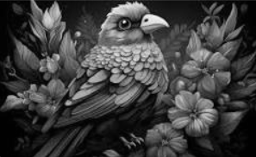
Output:
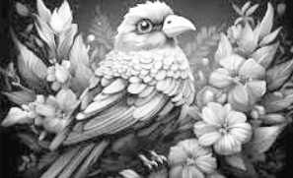

Result:
Thus, histogram equalization was successfully implemented using OpenCV, and the original gray-scale image was compared with the histogram-equalized image, showing improved contrast.

5. Histogram Analysis Based on Colour Levels using OpenCV
Aim
To write a Python function to analyse the histogram of an input image based on color levels using OpenCV.
Algorithm
- Read the input image.
- Split the image into blue, green and red channels.
- Calculate the histogram for each colour channel.
- Display the histograms.
- Display the input image.
Code:
import cv2
import matplotlib. pyplot as plt
def analyze_histogram(image):
colours = ('b', 'g', 'r')
for i, color in enumerate(colors):
histogram = cv2.calcHist([image], [i], None, [256], [0, 256])
plt.plot(histogram, color=color)
plt.title("Color Histogram")
plt. xlabel ("Colour Level")
plt. Ylabel ("Number of Pixels")
plt. show ()
image = cv2.imread("image.jpg")
if image is None:
print ("Error: Image not found!")
else:
cv2.imshow("Original Image", image)
analyze_histogram(image)

cv2.waitKey(0)
cv2.destroyAllWindows()
Input:
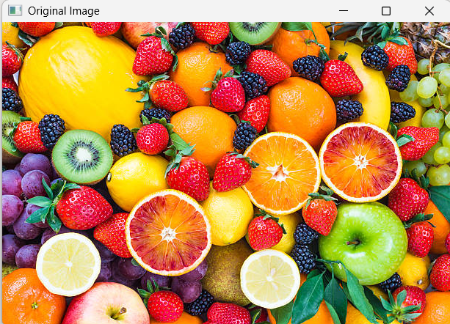
Output:
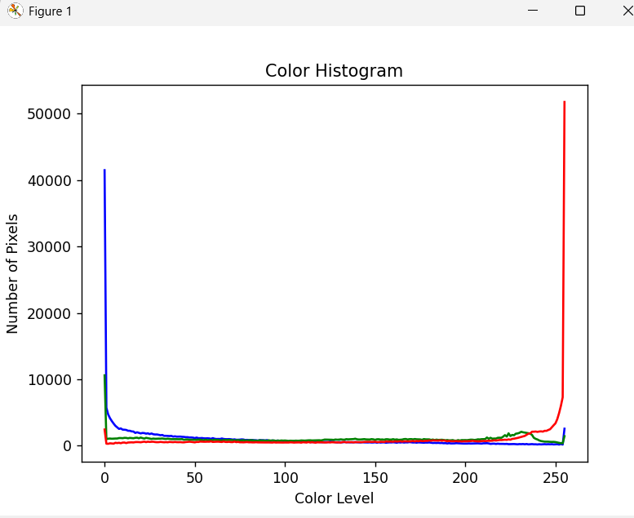
Result
Thus, the histogram of the input image was analyzed based on different color levels using OpenCV.

6. Erode an Image using Erode Function
Aim
To read an image in Python and perform image erosion using the OpenCV Erode function.
Algorithm
- Read the image.
- Create a kernel.
- Apply erosion using cv2.erode().
- Display the original and eroded images.
- Save the eroded image.
Code:
import cv2
import numpy as np
image = cv2.imread("image.jpg")
if image is None:
print("Error: Image not found!")
else:
kernel = np.ones((5, 5), np.uint8
eroded_image = cv2.erode(image, kernel, iterations=1)
cv2.imshow("Original Image", image)
cv2.imshow("Eroded Image", eroded_image)
cv2.imwrite("eroded_image.jpg", eroded_image)
print("Erosion applied successfully.")
print("Eroded image saved.")
cv2.waitKey(0)
cv2.destroyAllWindows()

Input:
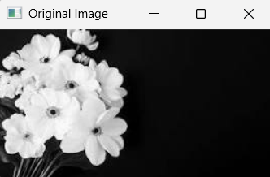
Output:
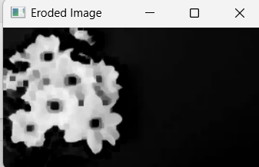
Result
Thus, the given image was successfully eroded using the OpenCV Erode function.

7. Video Processing – Slow Motion and Fast Motion
Aim
To read a captured video in Python and display the video in slow motion and fast motion using OpenCV.
Algorithm
- Read the video file.
- Open the video using VideoCapture().
- Read frames continuously.
- Display the video in slow motion.
- Display the video in fast motion.
- Stop when the video ends.

Code:
import cv2
from tkinter import Tk
from tkinter.filedialog import askopenfilename
# Open file selection window
Tk (). withdraw()
video_path = askopenfilename(
title="Select your video",
filetypes= [("Video Files", "*.mp4 *.avi *.mov *.mkv")]
)
# Open video
video = cv2.VideoCapture(video_path)
if not video. is Opened ():
print ("Error: Video could not be opened!")
else:
print ("Playing video in slow motion...")
# Slow Motion
while True:
ret, frame = video.read()
if not ret:
break
cv2.imshow("Slow Motion", frame)
if cv2.waitKey(100) & 0xFF == ord('q'):
break
video.release()
cv2.destroyAllWindows()
# Open video again
video = cv2.VideoCapture(video_path)

print("Playing video in fast motion...")
# Fast Motion
while True:
ret, frame = video.read()
if not ret:
break
cv2.imshow("Fast Motion", frame)
if cv2.waitKey(20) & 0xFF == ord('q'):
break
video.release()
cv2.destroyAllWindows()
print("Video processing completed.")
Input:
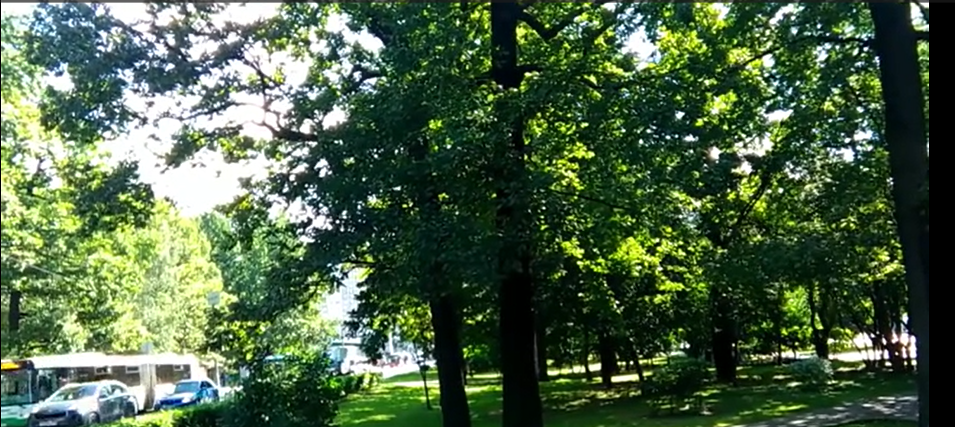
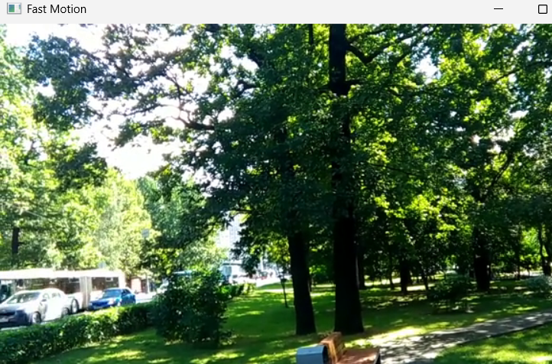
Output:
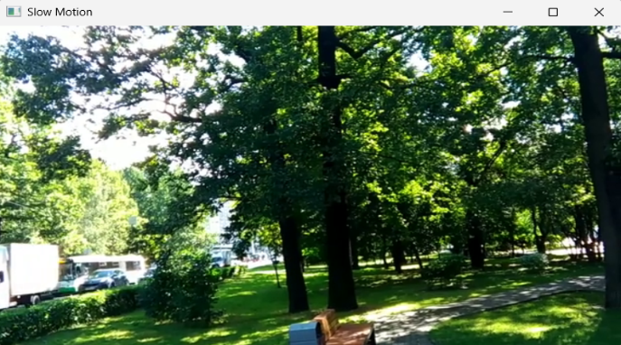
Result
Thus, the captured video was successfully read and displayed in slow and fast motion using OpenCV.

8. Dilate an Image using Dilate Function
Aim
To read an image in Python and perform image dilation using the OpenCV Dilate function.
Algorithm
- Read the input image.
- Create a kernel.
- Apply dilation using cv2.dilate().
- Display the original and dilated images.
- Save the dilated image.
Code:
import cv2
import numpy as np
image = cv2.imread("image.jpg")
if image is None:
print("Error: Image not found!")
else:
kernel = np.ones((5, 5), np.uint8)
dilated_image = cv2.dilate(image, kernel, iterations=1)
cv2.imshow("Original Image", image)
cv2.imshow("Dilated Image", dilated_image)
cv2.imwrite("dilated_image.jpg", dilated_image)
print("Dilation applied successfully.")
print("Dilated image saved.")
cv2.waitKey(0)
cv2.destroyAllWindows()
Input:
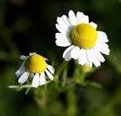
Output:
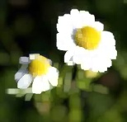
Result
Thus, the given image was successfully dilated using the OpenCV Dilate function.

9. Image Scaling – Bigger and Smaller Sizes
Aim
To implement image scaling techniques to resize an image into bigger and smaller sizes using OpenCV.
Algorithm
- Read the image.
- Resize the image to a bigger size.
- Resize the image to a smaller size.
- Display all three images.
- Save the resized images.

Code:
import cv2
image = cv2.imread("image.jpg")
if image is None:
print("Error: Image not found!")
else:
bigger = cv2.resize(image, None, fx=2, fy=2)
smaller = cv2.resize(image, None, fx=0.5, fy=0.5)
cv2.imshow("Original Image", image)
cv2.imshow("Bigger Image", bigger)
cv2.imshow("Smaller Image", smaller)
cv2.imwrite("bigger_image.jpg", bigger)
cv2.imwrite("smaller_image.jpg", smaller)
print("Image resized successfully.")
cv2.waitKey(0)
cv2.destroyAllWindows()
Input:
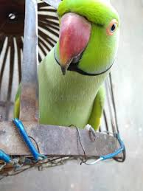

Output:
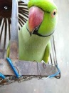
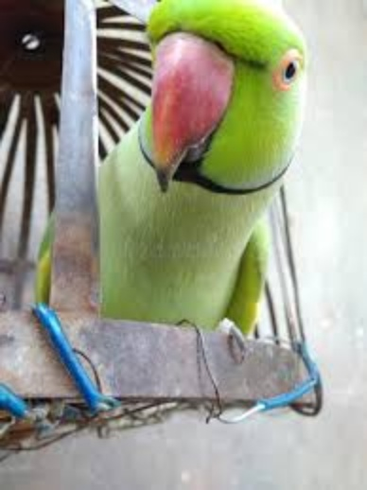
Result
Thus, the input image was successfully resized into bigger and smaller sizes using OpenCV.

10. 90-Degree Clockwise Rotation
Aim
To rotate the given image by 90 degrees clockwise using OpenCV.
Algorithm
- Read the input image.
- Apply 90-degree clockwise rotation.
- Display the original and rotated images.
- Save the rotated image.
Code:
import cv2
image = cv2.imread("image.jpg")
if image is None:
print ("Error: Image not found!")
else:
rotated = cv2.rotate(image, cv2.ROTATE_90_CLOCKWISE)
cv2.imshow("Original Image", image)
cv2.imshow("90 Degree Clockwise Image", rotated)
cv2.imwrite("rotated_image.jpg", rotated)
print ("Image rotated by 90 degrees clockwise.")
print ("Rotated image saved.")
cv2.waitKey(0)
cv2.destroyAllWindows()
Input: Output:
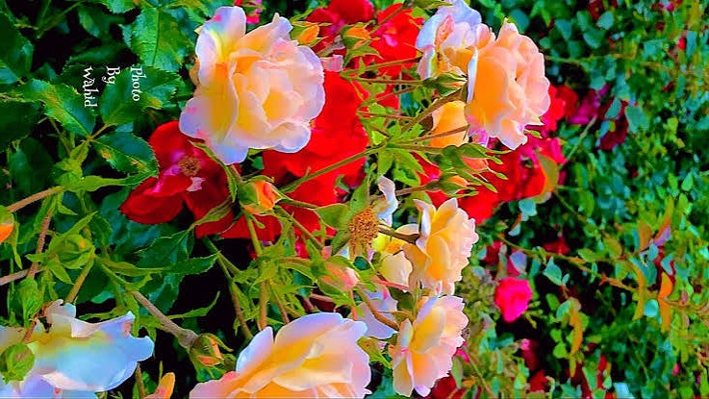
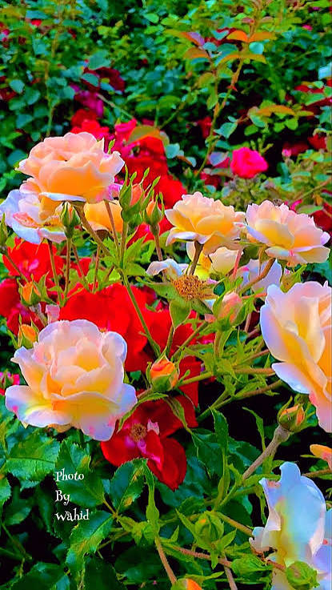

Result
Thus, the given image was successfully rotated by 90 degrees clockwise using OpenCV.

